PgCert Academic Practice in Art, Design and Communication
Action Research Project Ethical Enquiry Form

Participant name: Joel Simpson

Cohort: 2

Tutor name: John O’Reilly / Mallika Kanyal

- What is your research question?

How can the facilitation of a community-facing event inform students’ ideas about the possibilities for art practitioners in community organisations?

- Who will be providing you with information to help you answer your question, and how will you approach and/or select them?
BA Fine Art Y3 students at Chelsea College of Arts who are involved in the Land Trust Artist Residency project. These students have responded to an open call-out to any students interested in the project at the end of last academic year and the beginning of this one.

When they became involved in the project, I shared some information with them about my research and asked via email and in person if anyone from the group would be willing to participate in my research. Their verbal and online responses were then followed up with consent forms.

- What will you be asking participants to do?

Students will be supporting the facilitation of an event which will bring together future residents of a self-build, community-led housing development (RUSS CLT) and existing residents of the street that the development is on (Church Grove, Ladywell). Specifically, they will be asked to produce artworks that enable inclusivity within the event. They will have the opportunity to work with myself, future RUSS residents and existing Church Grove neighbours to explore their ideas for the artworks.
I will be asking if students to consent to their participation in the residency project being documented by myself (reflecting on their ideas about the role of artist in community contexts and the ways in which this potentially transforms), which includes:

- consent to their participation in the project being observed, documented and reflected on by me for the purposes of the PgCert

- consent to a 25-minute semi-structured interview with myself, where I will invite them to interpret the artworks they’ve created for the neighbours event with me

- How will you get informed consent from these participants?

I will send students participating in the project a PDF brief listing the above components for which I’m requesting their consent. This document will also specify where information will be stored and how the research will be shared. I will print off copies and ask them to sign in person at the end/beginning of a project meeting, emphasising that they can consent to some but not all (and of course none) of the above if they prefer.

I will also explain in this document that if participants wish to be involved in the residency project but not in my research, they are welcome to do so – and non-participation does not impact the teaching and learning components of the project. I will make it known that they are allowed to withdraw their consent at any time, and that they do not have to state the reasons why. I will also establish moments over the course of the project where they can offer evaluative feedback to me anonymously through Google forms, in order to ensure that they are not feeling pressured by their participation and to ensure that I can implement changes according to these suggestions.

- What potential risks to the interests of participants do you foresee and what steps will you take to minimise those risks? A participant’s interests include their physical and psychological wellbeing; their commercial interests; and their rights of privacy and reputation.
I’m exploring the possibility that the students’ ideas about artists in community organisations, and thus their idea of their own agency in these spaces, may be transformed. One risk here is that students could feel embarrassed or judged for their contributions, both in the “before” of the event as well as in the “after”. In order to address this, I will emphasise that they can withdraw participation from my project at any time, and I will also offer both anonymous and in-person opportunities throughout for the students to voice their concerns so that we can amend the activities and their participation in my research accordingly.

Additionally, this is a project where the students will lead on facilitating activities with the residents of a community land trust and their neighbours. Therefore, students will be encountering and working collaboratively with members of the wider community in the lead-up and during the event. While I will be there throughout, alongside my colleague who will also attend periodically, there may some moments where activities are happening in separate areas of the same premises. The risks that this poses will be identified in a UAL Health and Safety Risk Assessment form which myself and my colleague will fill out. Through this assessment, risks related to working with community members will need to be addressed with a protocol that all students are aware of. Students will be advised to remove themselves from a situation immediately, and must report any unusual or threatening behaviour to myself or to my colleague as soon as they can. They will be signposted towards counselling services provided by the university before the event, so that if anything does happen, whether they share it with myself or not, there are resources to support them.

- What potential risks to yourself as the practitioner do you foresee and what steps will you take to minimise those risks?

The risks to myself are the same as the above as I will also be interacting with individuals who I have not met yet. I will report any behaviour to the land trust and we will discuss any follow-up actions. This reporting is a straightforward process as I am a trustee of the land trust and am thus able to contact the board of trustees directly at any opportunity.

- Does your project involve children or vulnerable adults e.g. a person with a learning disability?

No.

- How will you store the information you gather from participants?

I will outline in the brief given to students that information will be stored by myself in a password protected laptop for up to a year after the completion of the ARP, and will not be held by any other parties. I will outline that I will retain this information for this length of time so that I can reflect only the ARP in the immediate aftermath and in the planning of future projects. I will make it clear that in the ARP presentation, I will anonymise all students.

I confirm my responsibility to deliver the project in accordance with the Code of Practice on Research Ethics of the University of the Arts London (the University). In signing this form I am also confirming that:

- The form is accurate to the best of my knowledge and belief.
- I understand and accept that the ethical propriety of this project may be monitored by the relevant College Research body and/or the University’s Research Ethics Sub-Committee.
Signed: Joel Simpson Date: 13 December 2023

I support this project and have reviewed it with the participant:
Signed: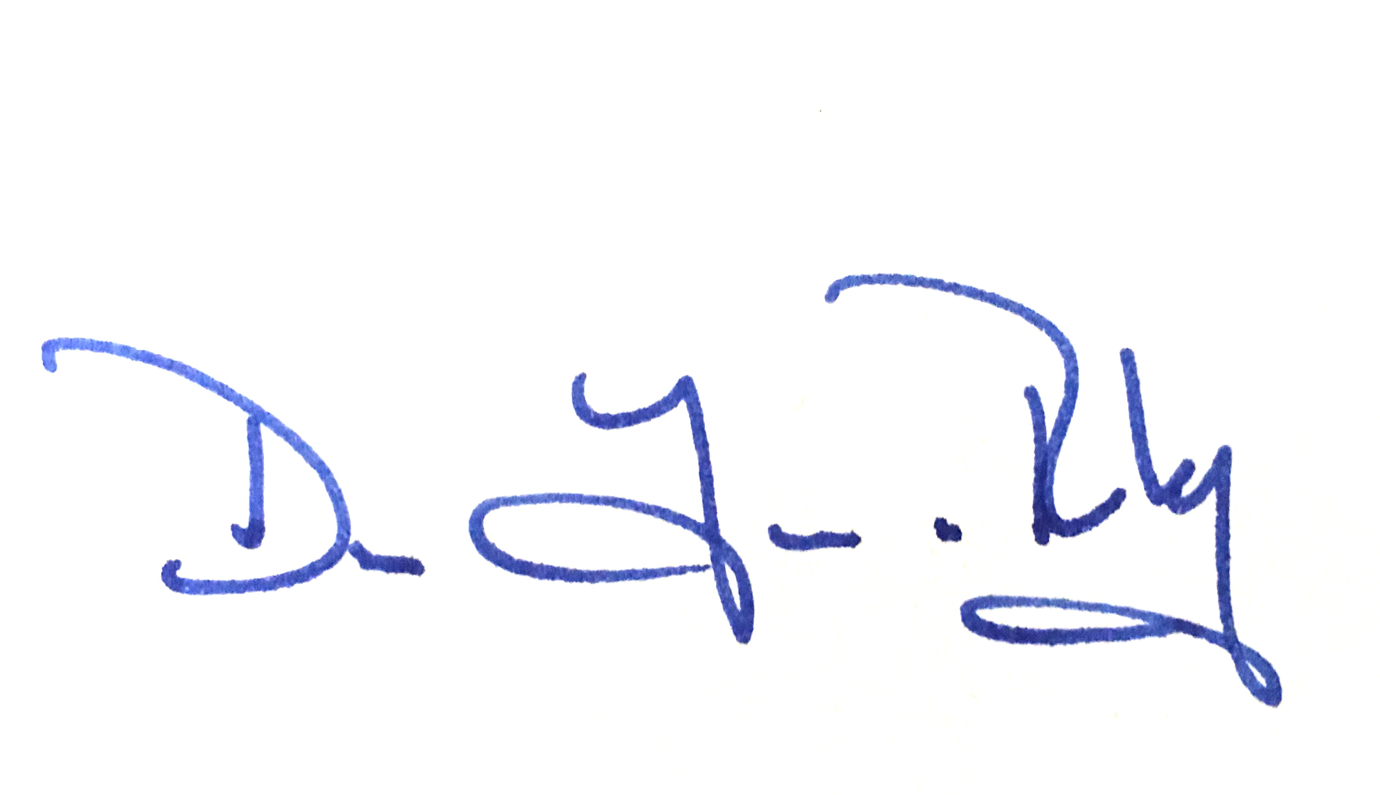 Date: 15.12.23

